Braking Distance

The data are the braking distances of 10 cars for each of two different makes, Bluemobile and Accacia. The cars were driven on a test track at 50 km/h. The distance it took for each car to come to a complete stop was measured from when the brakes were applied.

Each bar represents the distance in meters it took for each car to stop. The ten blue bars represent the Bluemobile cars and the ten yellow bars the Accacia cars.

In creating a context for the activity, students can be asked to help someone (e.g., the teacher or someone known by her) to decide which car would be the best type of car to buy based on the data, if it is a priority to have a car that stops fast. A conversation can be held about the safety features of cars, including "braking" behaviour.

Braking distances – sorted by color

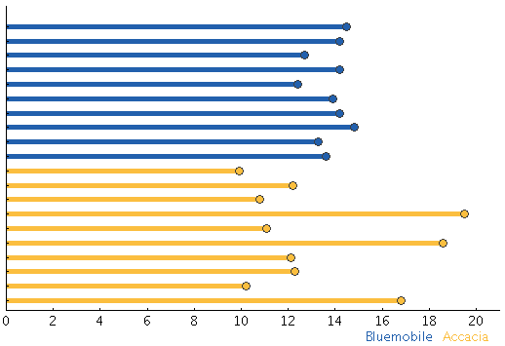

Braking distances – sorted by size

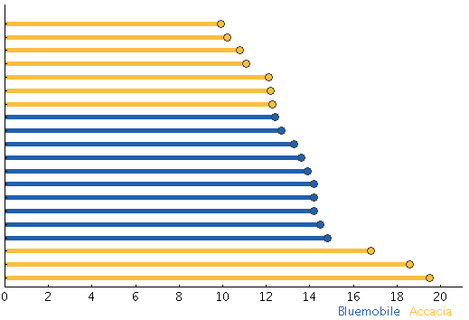

Braking distances – sorted by color and size

